**Weather Forecasting System and**

**Soil Moisture Analyser**

Arnav Jha (RA2011029010026), Anik Sau (RA2011029010027)

School of Computing, College of Engineering and Technology,

SRM Institute of Science and Technology, Kattankulathur, Chennai - 603203

**Abstract:**

The scarcity of clean water resources around the globe has generated a need for optimum utilization. Internet of Things (IoT) solutions, are bridging the gaps between the cyber and physical worlds, based on the application specific sensors’ data acquisition and intelligent processing. IOT based Weather Forecasting System and Soil Moisture Analyser for farmers aims to ensure higher productivity of crops using optimum water-resource utilization in the precision farming and lower the risk of weather hazards. This paper presents a technology based smart system to predict the irrigation requirements of a field using the sensing of ground parameter like soil moisture, soil temperature, and environmental conditions along with the weather forecast data from the Internet. The proposed system has been developed and deployed on a pilot scale and is based on a smart algorithm, which considers sensed data along with the weather forecast parameters like precipitation, air temperature, wind speeds, humidity.The sensor node data is wirelessly collected using webservices and a web-based information visualization and decision support system provides the real-time information insights based on the analysis of sensors data and weather forecast data.

**Keywords:** Internet of Things (IoT), sensors, precision farming, weather hazards, smart algorithm.

1. **Introduction:**

In India, 70% of the economy depends on agriculture and there is a need to modernize the conventional agricultural practices for the better productivity. Due to unplanned use of water the ground water level is decreasing day by day, lack of rains and scarcity of land water also results in decrement in volume of water on earth. Weather forecasting has been a standout amongst the most experimentally and technologically troublesome issues over the world and thus it ends up hard predicting weather here and now with effectiveness. Due to the climatic changes and lack of precision; agriculture has resulted in poor yield as compared to population growth.

This paper presents a system that predicts soil moisture based on the information collected from the sensors deployed at the field and the weather forecast available on the Internet. The field data has been collected through a sensor node. The software has been developed with node side connectivity, information visualization and decision support features. The algorithm for soil-moisture prediction, is based on Machine Learning techniques applied on the sensor node data and the weather forecast data. The proposed approach utilizes Naive Bayes and Chi Square strategy for weather forecasting, where state of weather is classified in some attribute like as temperature, humidity, and wind and using the attributes the system predicts the weather as good or bad.

1. **Literature Survey:**

The following table acknowledges the Papers studied and the inferences obtained.

|  |  |  |  |  |
| --- | --- | --- | --- | --- |
| Sl. No. | Paper Name | Month & Year of Publication | Authors | Inference |
| 1 | IoT-based data logger for weather monitoring using  Arduino-based Wireless Sensor Networks with remote graphical and application alerts | January, 2021 | Jamal Mabrouki,  Mourade Azrour,  Driss Dhiba,  Yousef Farhaoui,  Souad El Hajjaji | This Journal provides insights on automatic weather monitoring system that allows having dynamic and real-time climate data of a given area, which is the backbone of this project. With the provided statistical data, we sensed the need for monitoring and prediction of soil texture and moisture index along with the changes within the climate parameters. |
| 2 | Weather Radar and Rain-Gauge Data Fusion for Quantitative Precipitation Estimation: Two Case Studies | March, 2020 | Fabrizio Cuccoli,  Luca Facheris,  Andrea Antonini,  Samantha Melani,  Luca Baldini | An early warning of severe rainfall through a timely and accurate estimation is crucial for reducing the hydrological risk. Moreover, the rain-gauge networks are often not able to detect rainfall due to their limited sampling capability. |
| 3 | Automatic Weather Monitoring Analysis for Renewable Energy System | July, 2020 | U. Ramani,  R. Nithya,  S. Sathieshkumar,  T. Santhoshkumar | After analysing the paper, we inferred about the sustainable availability of a weather monitoring systems for our farmers without the hassle of complex processing units. |
| 4 | IoT Based Air Quality and Weather Monitoring System with Android Application | February, 2022 | Ashfaqul Haq,  Sayed Sahriar Hasan,  Md. Zillur Rahman,  Dipesh Das,  Ata Ullah | In today’s world, weather and climate conditions have become unpredictable, which can lead to the destruction of agricultural productivity. There is an urgent need for a real-time local weather station that can keep farmers informed of current weather conditions and to quantify harmful substances in air particles. |
| 5 | Weather Monitoring System AIoT Based for Oil Palm Plantation Using Recurrent Neural Network Algorithm | November, 2021 | Prasetyo Mimboro,  Ford Lumban Gaol,  Harco Lesie Hendric Spits Warnars,  Banefano Soewito | The purpose of this research is to develop an IoT device with an artificial neural network algorithm embedded in the device to predict weather conditions in real-time. This delineates the description of the IoT system using the Recurrent Neural Network (RNN) algorithm and provides with the real time statistics for a particular crop type. |

1. **Architecture:**
   1. **Hardware Setup**

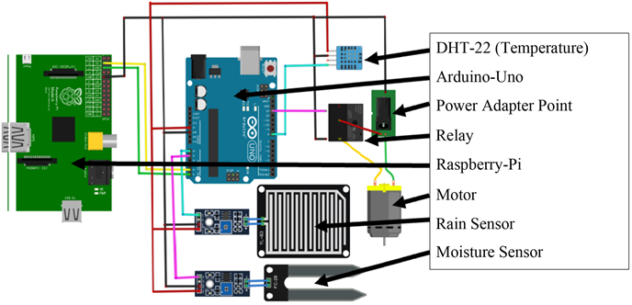

**Tools**

Following is a list of different tools of proposed project.

1) Raspberry Pi 3B

2) Arduino UNO

3) Temperature & Humidity sensor (DHT-22)

4) Soil moisture sensor

6) Motor

7) Router

**Software Requirements**

1) IDLE (python 2.6.)

2) Sqlite3

* 1. **System Design**

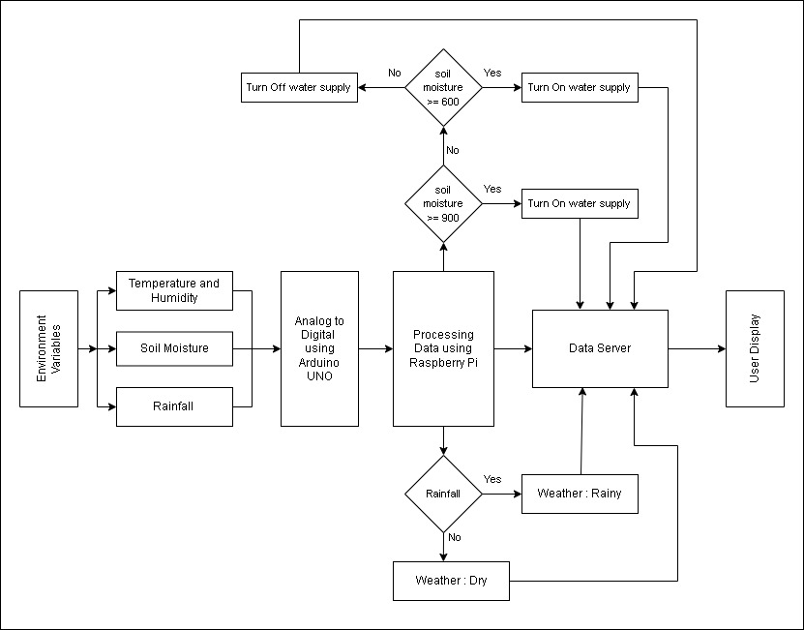

1. **Algorithms**

The work of, data classification has been performed using two data mining technique: Chi square test and Naive Bays Statistics. The classified data is called training dataset, is fixed and by using this data with testing data, Weather Forecast will be possible. The algorithm of chi square and naïve bays finds relationships between the values of the predictors and the values of the target. The model gains output from the training set and that dataset is used.

* 1. **Chi Square Algorithm**

Chi Square Algorithm is a predictive technique used to determine whether there is a significant difference between the expected frequencies and the observed frequencies in one or more categories. The Equation is as follows:

**χ2 = ∑(Oi – Ei)2/Ei,**

where Oi = observed value (actual value) and Ei = expected value.

In our project we use chi square statistic to determine the best attribute of weather forecast.

* 1. **Naïve Bayes Algorithm**

Naïve Bayes Algorithm is a classification technique based on Bayes Theorem. Naïve Bayes is easy to build and very much useful for large datasets. By using the Naïve Bayes equation, we can find the future probability. The Equation is as follows: $p\left(\left.c\right|x\right)=\frac{p\left(\left.x\right|c\right) p\left(c\right)}{p_{\left(x\right)}}$

where, (c|x) is future probability of class (c, target), P(c) is the prior probability of the class, P(x|c) is the likelihood which is the probability of predictor given class, P(x) is the prior probability of predictor.

The condition of predicting weather of our project is as follows:

Class:

C1: Weather Forecasting = ‘Good’,

C2: Weather Forecasting = ‘Bad’.

1. **Output and Results**

In this result, local server shown a smart agriculture farm weather monitoring system in 10 second time interval. It showed four parameters, temperature, soil moisture, rain detection.

|  |  |  |  |
| --- | --- | --- | --- |
| Date &Time | Temp  (℃) | Soil  Moisture | Rainfall |
| 2022-11-13  10:40:32 | 30℃ | 999  Moisture 0 | 247  Raining |
| 2022-11-13  11:40:32 | 30℃ | 1001  Moisture 0 | 483  Raining |
| 2022-11-13  12:40:32 | 30℃ | 347  Moisture Lvl 1 | 564  Raining |
| 2022-11-13  13:40:32 | 30℃ | 310  Moisture Full | 253  Raining |
| 2022-11-13  14:40:32 | 30℃ | 320  Moisture Full | 181  Dry |
| 2022-11-13  15:40:32 | 30℃ | 300  Moisture Full | 247  Dry |

1. **Conclusion:**

The soil moisture and weather reports remain a critical parameter for developing a smart system for farming and irrigation. The soil moisture is affected by a number of environ- mental variables, e.g., air temperature, air humidity, UV, soil temperature, etc. Advancement in technologies has led the weather forecasting accuracy to improve significantly and the weather fore- casted satellite data can be used for prediction of soil moisture and changes in level incurred over the time period. This paper proposes an IoT based smart architecture along with a machine learning based approach to predict the soil moisture. The algorithm which has been proposed uses sensors’ data of recent past and the weather forecasted data for prediction of soil moisture. The predicted value of the soil moisture in terms of their accuracy and error rate is far better. Further, the approach to integrate into a standalone system prototype is cost effective as it is solely based on open standard technologies, which are easier to implement. It can be further customized for application specific scenarios.

1. **Future Scope:**

The machine learning requires a large amount of data so our recorded meteorological data helps in improving the performance. The future work is to is to infuse the above-mentioned technology in order to generate a notational grid, which simplifies the weather data for the regional farmers by analysing the data based on the soil and weather conditions. Moreover, with the help of Integrated Forecasting System (IFS) and the data assimilation through satellites systems, Soil Moisture and Ocean Salinity (SMOS) data can be procured to notify the farmers regarding the soil moisture and air temperature forecast in the short range at regional scale. Incorporation of more weather attributes and conditions to predict and to work with other classification algorithms can be done to improve the accuracy.

This paper can further be enhanced with camera records for checking the discoloration of leaves and check out for plant diseases. With the deployment of AI and surveillance future three weeks weather predictions remains the biggest challenge to incorporate for betterment of the farmers.

1. **References:**

[1] A. Abdullah, S. A. Enazi and I. Damaj, "AgriSys: A smart and ubiquitous controlled-environment agriculture system," 2016 3rd MEC International Conference on Big Data and Smart City (ICBDSC), Muscat, 2016, pp. 1-6.

[2] A. Gheith, R. Rajamony, P. Bohrer, K. Agarwal, M. Kistler, B. L. W. Eagle, C. A. Hambridge, J. B. Carter, and T. Kaplinger, “Ibmbluemix mobile cloud services, “IBM Journal of Research and Development, vol. 60, no. 2-3, pp. 7:1–7:12, March 2016.

[3] H. Saini, A. Thakur, S. Ahuja, N. Sabharwal, and N.Kumar, “Arduino based automatic wireless weather station with remote graphical application and alerts”, in 2016 3rd International Conference on Signal Processing and Integrated Networks (SPIN), Feb 2016, pp. 605–609.

[4] A.V. Bosisio and M. P. Cadeddu, “Rain detection from ground based radiometric measurements: Validation against rain sensor observations,” in 2015 IEEE International Geo-science and Remote Sensing Symposium (IGARSS), July 2015, pp. 2323–2326.

[5] Y. Zhou, Q. Zhou, Q. Kong, and W. Cai, “Wireless temperature amp; humidity monitor and control system,” in 2012 2nd International Conference on Consumer Electronics, Communications and Networks (CECNet), April 2012, pp. 2246–2250.

[6] Pandey, V.S., Sharma, D., Shukla, A.K., Tyagi, S., 2017. A low-cost zigbee based temperature and humidity acquisition system for research and industrial applications. In: Dutta, C.R.K.S.D.K. (Ed.), International Conference on Communication Computing and Networking, pp. 379–385.